Net Banking style login:
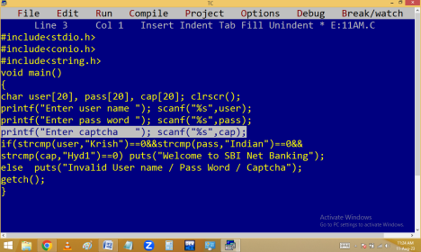
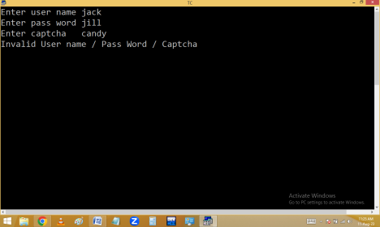
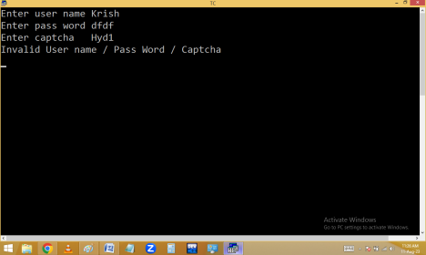Read a stu id, name, 6 sub marks. Find stu tot, avg and grade using below table.
Avg | Grade
>=75 | Distinction
>=60 | 1st Class
>=50 | 2nd
>=35 | 3rd
<35 | Fail

#include<stdio.h>
#include<conio.h>
#include<string.h>
void main()
{
int id, tel,eng,hin,mat,sci,soc,tot;
char name[20], grade[20];
float avg;
clrscr();
printf("Enter stu id, name, 6 sub marks ");
scanf("%d %s %d %d %d %d %d
%d",&id,name,&tel,&eng,&hin,&mat,&sci,&soc);
tot=tel+eng+hin+mat+sci+soc;
avg=tot/6.0;
if(tel>=35&&eng>=35&&hin>=35&&mat>=35&&sci>=35&&soc>=35) {
if(avg>=75)strcpy(grade,"Distinction");
else if(avg>=60) strcpy(grade,"1st class");
else if(avg>=50) strcpy(grade,"2nd class");
else strcpy(grade,"3rd class");
}
else strcpy(grade,"Fail");
puts("Id\tName\tTot\tAvg\tGrade");
puts("--------------------------------------------------------------");
printf("%d\t%s\t%d\t%.2f\t%s",id, name, tot, avg, grade); getch();
}
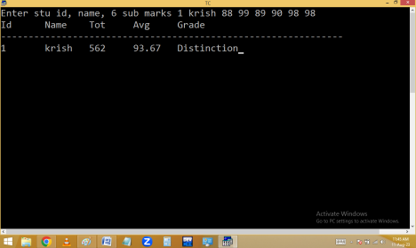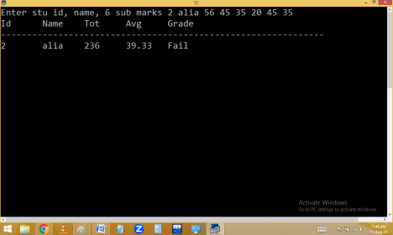
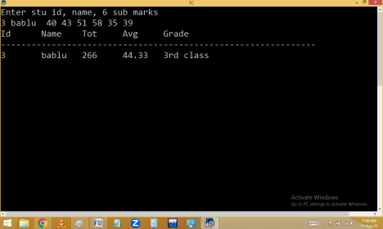Without using strcpy():
#include<stdio.h>
#include<conio.h>
void main()
{
int id, tel,eng,hin,mat,sci,soc,tot;
char name[20];
float avg;
clrscr();
printf("Enter stu id, name, 6 sub marks ");
scanf("%d %s %d %d %d %d %d
%d",&id,name,&tel,&eng,&hin,&mat,&sci,&soc);
tot=tel+eng+hin+mat+sci+soc;
avg=tot/6.0;
puts("Id\tName\tTot\tAvg\tGrade");
puts("--------------------------------------------------------------"); printf("%d\t%s\t%d\t%.2f\t",id, name, tot, avg);
if(tel>=35&&eng>=35&&hin>=35&&mat>=35&&sci>=35&&soc>=35) {
if(avg>=75)puts("Distinction");
else if(avg>=60)puts("1st class");
else if(avg>=50) puts("2nd class");
else puts("3rd class");
}
else puts("Fail");
getch();
}
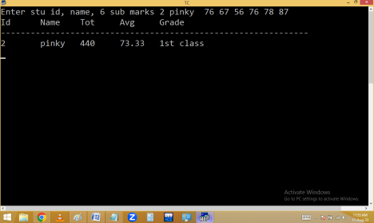
Read a person age and gender and determine that person is eligible for marriage or not.
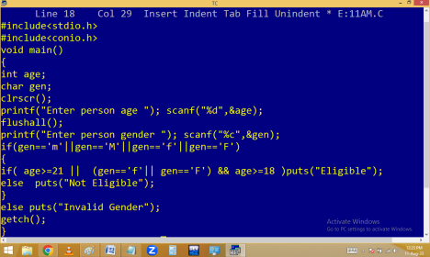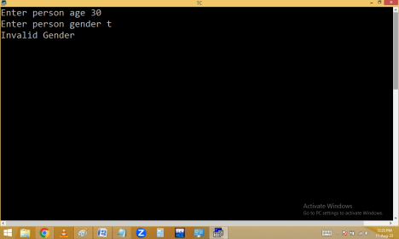
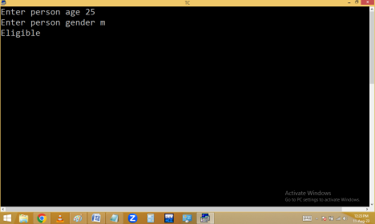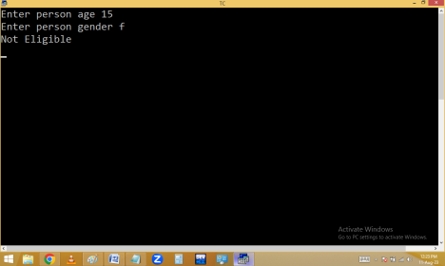
Electricity bill generation:
DOMESTIC SLAB SYSTEM
UNITS | UNIT PRICE
1-50 | 1.45
51-100 | 2.80
101-200 | 3.05
201-300 | 4.75
301-500 | 6.00
>500 | 6.25

30 UNITS = 30*1.45 = 43.5
80 UNITS = 50*1.45 + 30*2.8=156.5
180 UNITS =

